# DIS-US-Cul-Mississippian-Gorget- HUITHLEWALLI SITE, ALABAMA

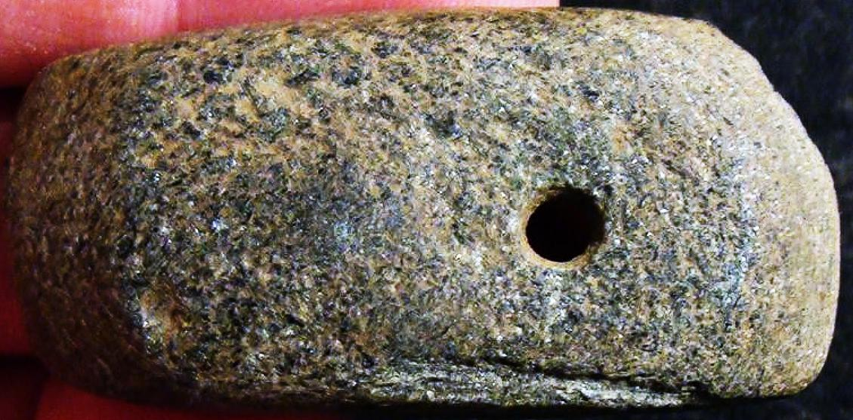

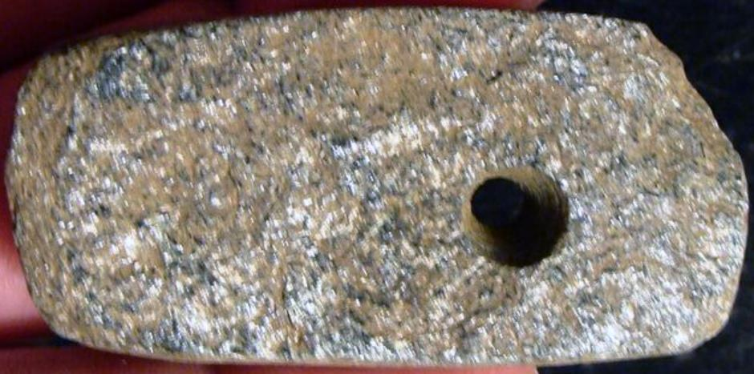

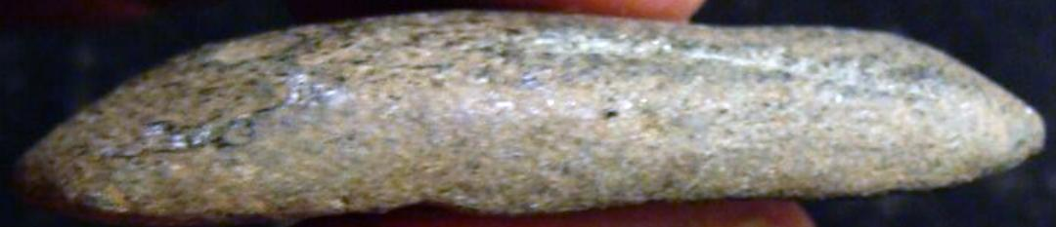

# GORGET/-EX BURKE-HUITHLEWALLI SITE, ALABAMA

SINGLE DRILLED HOLE STONE GORGET/-

MEASURES 1 1/8 INCHES HIGH AND 2 1/8 INCHES WIDE

FROM THE COLLECTION OF DR. R.P. BURKE OF ELMORE COUNTY, ALABAMA.

FOUND AT HUITHLEWALLI, ALABAMA

# Moundville Complex in the Pickwick Basin

Sold by [plantations](http://myworld.ebay.com/plantations) ( [16977](http://feedback.ebay.com/ws/eBayISAPI.dll?ViewFeedback&userid=plantations) )

### Delivery package 1 of 1

Estimated delivery Thursday, Oct 8, 2015 - Monday, Oct 12, 2015

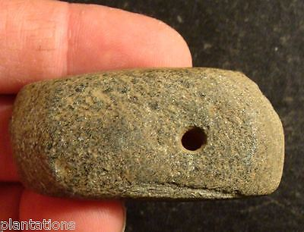

#### [SINGLE DRILLED HOLE STONE GORGET/-EX BURKE-HUITHLEWALLI SITE, ALABAMA](http://www.ebay.com/itm/231665915679)

|  |  |
| --- | --- |
| Item price | $55.00 |
| Quantity | 1 |
| Item number | 231665915679 |
| Shipping service | USPS Priority Mail |

## Shipping address

Ralph J Coffman Jr

149 Atlantic Ave

Swampscott MA 01907-2427

United States

## Order total

|  |  |
| --- | --- |
| Subtotal | $55.00 |
| Shipping | Free |

**Total**

$55.00